‘Nabokov & Morality’ Symposium
Thursday 5th May & Friday 6th May 2011
Graham Hills Room 5.14

Title: …….. Surname: ………………………………… Forename:……….……………………..

University / Organisation: ……………………………………………………………………………….

Job Title/Level of Study: ………………………………………………………………...

Address: …………………………………………………………………………………………………

……………………………………………………………………………………………………………

……………………………………………………………………………………………………………

Tel: ……………………………………… Fax: ………………………………………………….

Email: .……….…………………………………………………………………………………………..

Special Needs/Dietary Requirements:

If you have any dietary or accessibility requirements, please detail below:

……………………………………………………………………………………………………………

……………………………………………………………………………………………………………

Please enclose a cheque made payable to the ‘University of Strathclyde’ for either £25 (two-day attendance) or £12.50 (single day). If the latter, please detail what day you are attending.

Please then send cheques and completed registration forms to:

Claire McConnell,
RaKET, Room LT417, Livingstone Tower,
University of Strathclyde,
26 Richmond Street,
Glasgow
Scotland
G1 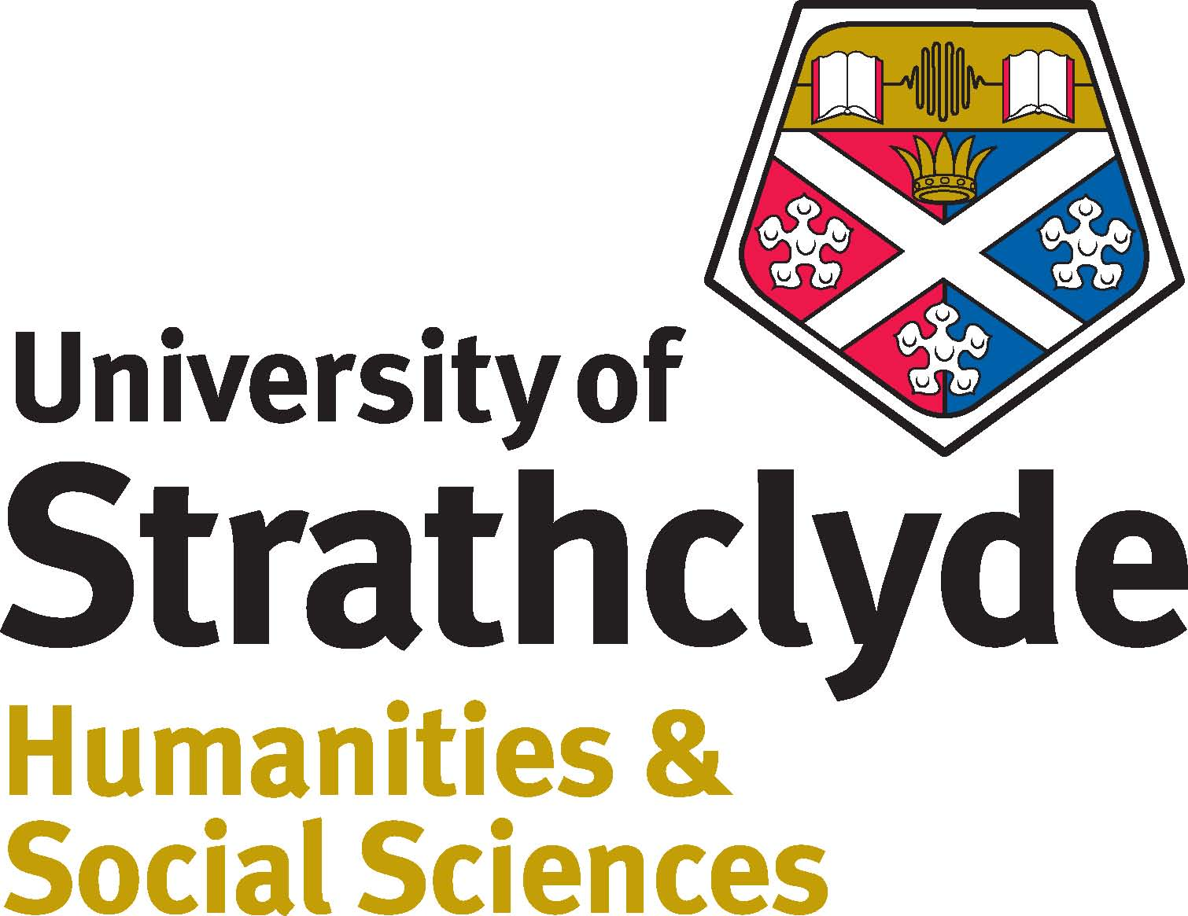1XH

